**Docker push problems:**

Troubleshoot step:

1.Docker image build

docker build –t hima-app:latest .

2.create a repo on docker hub

3.docker logout

4.tag the image:

docker tag imagename:version dockerreponame:version

eg: docker tag hima-app:latest himarepo/himashree-app:latest

5.docker login

6.docker push himarepo/himashree-app:latest

Error:

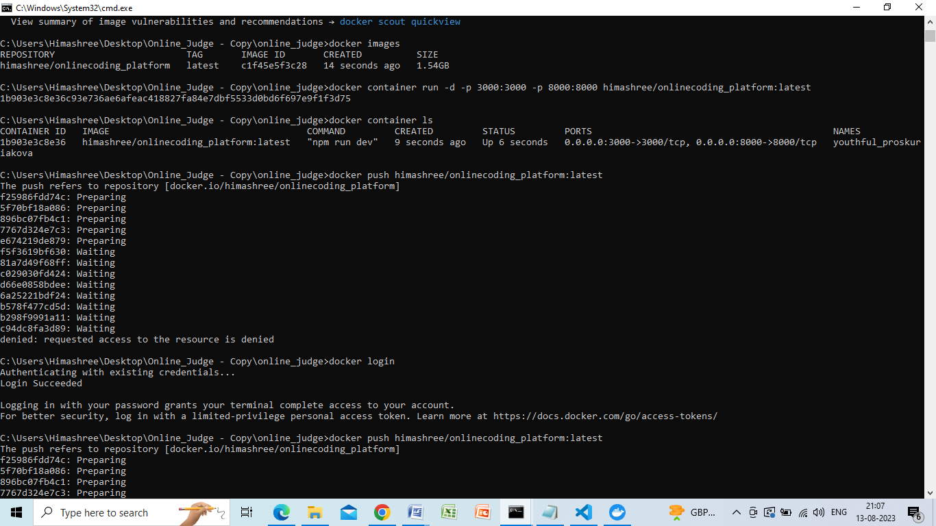

Solution:

